Creating and Running Docker Containers in different ways

Senario
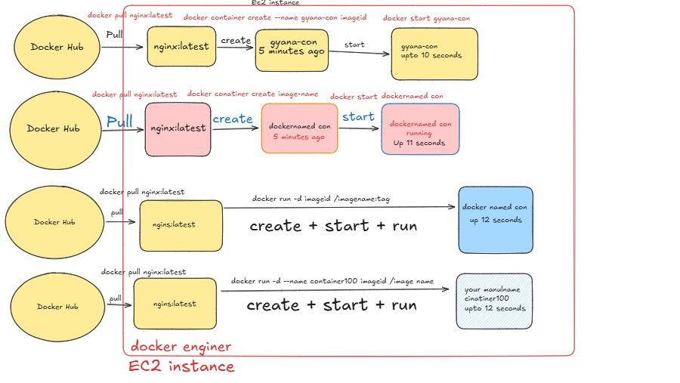

Step-1
Lunching an EC2 instance using the Ubuntu AMI.
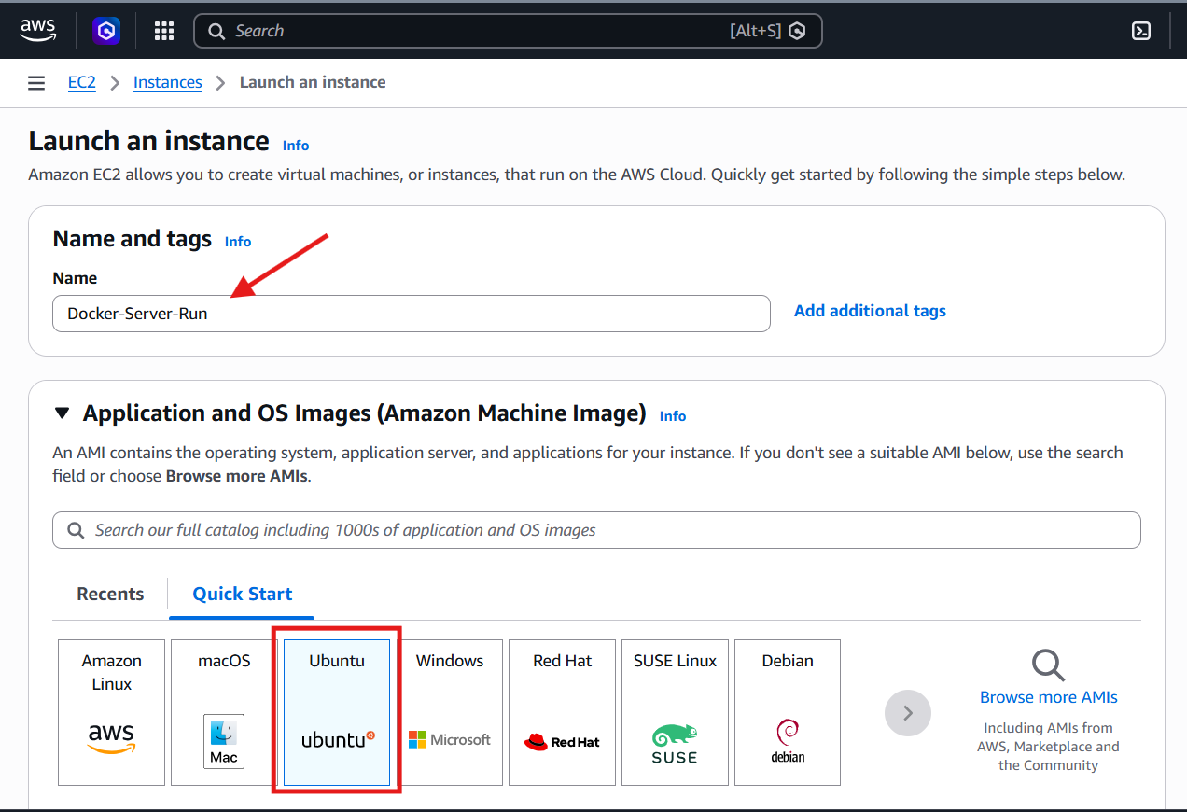
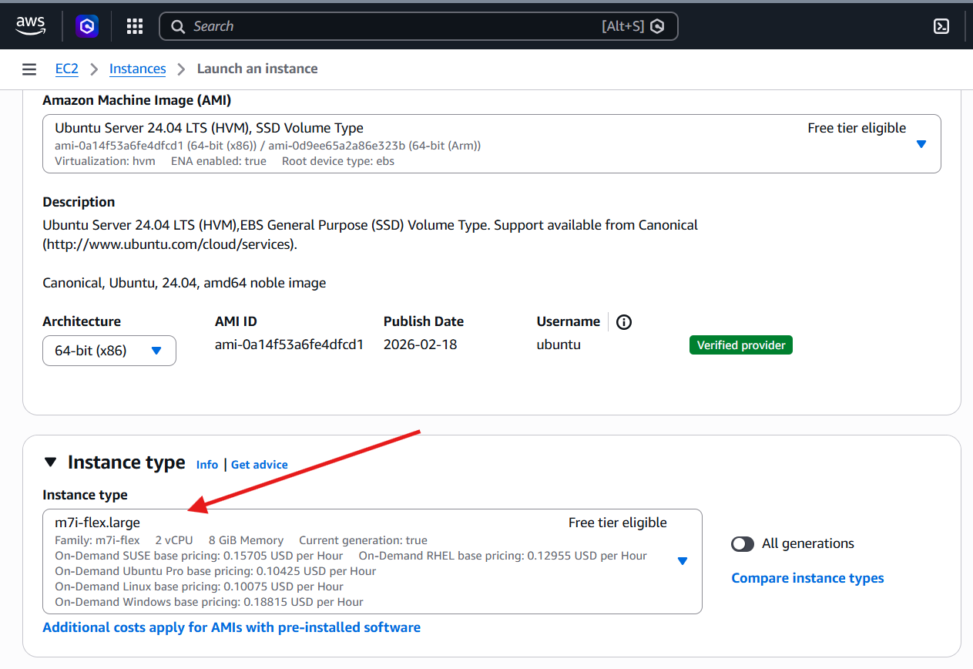
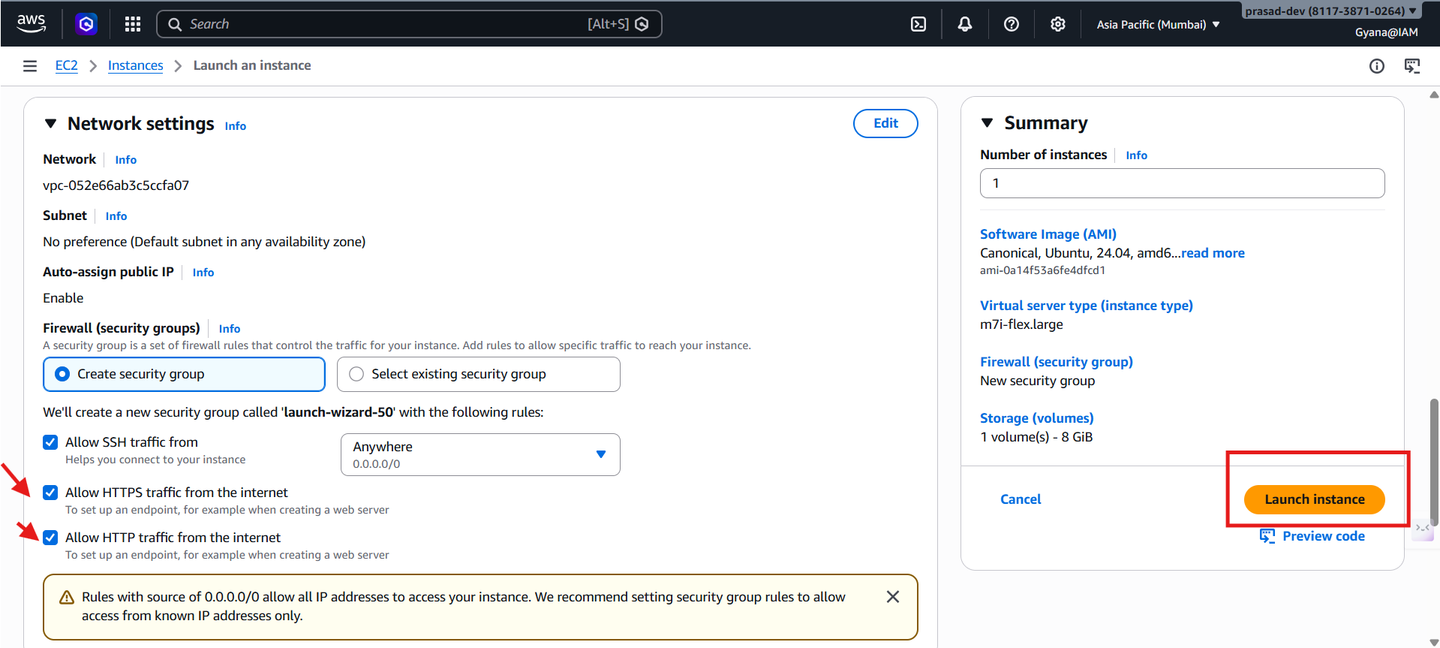
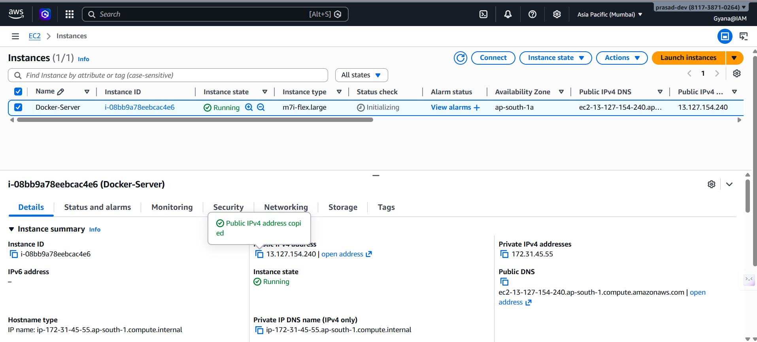
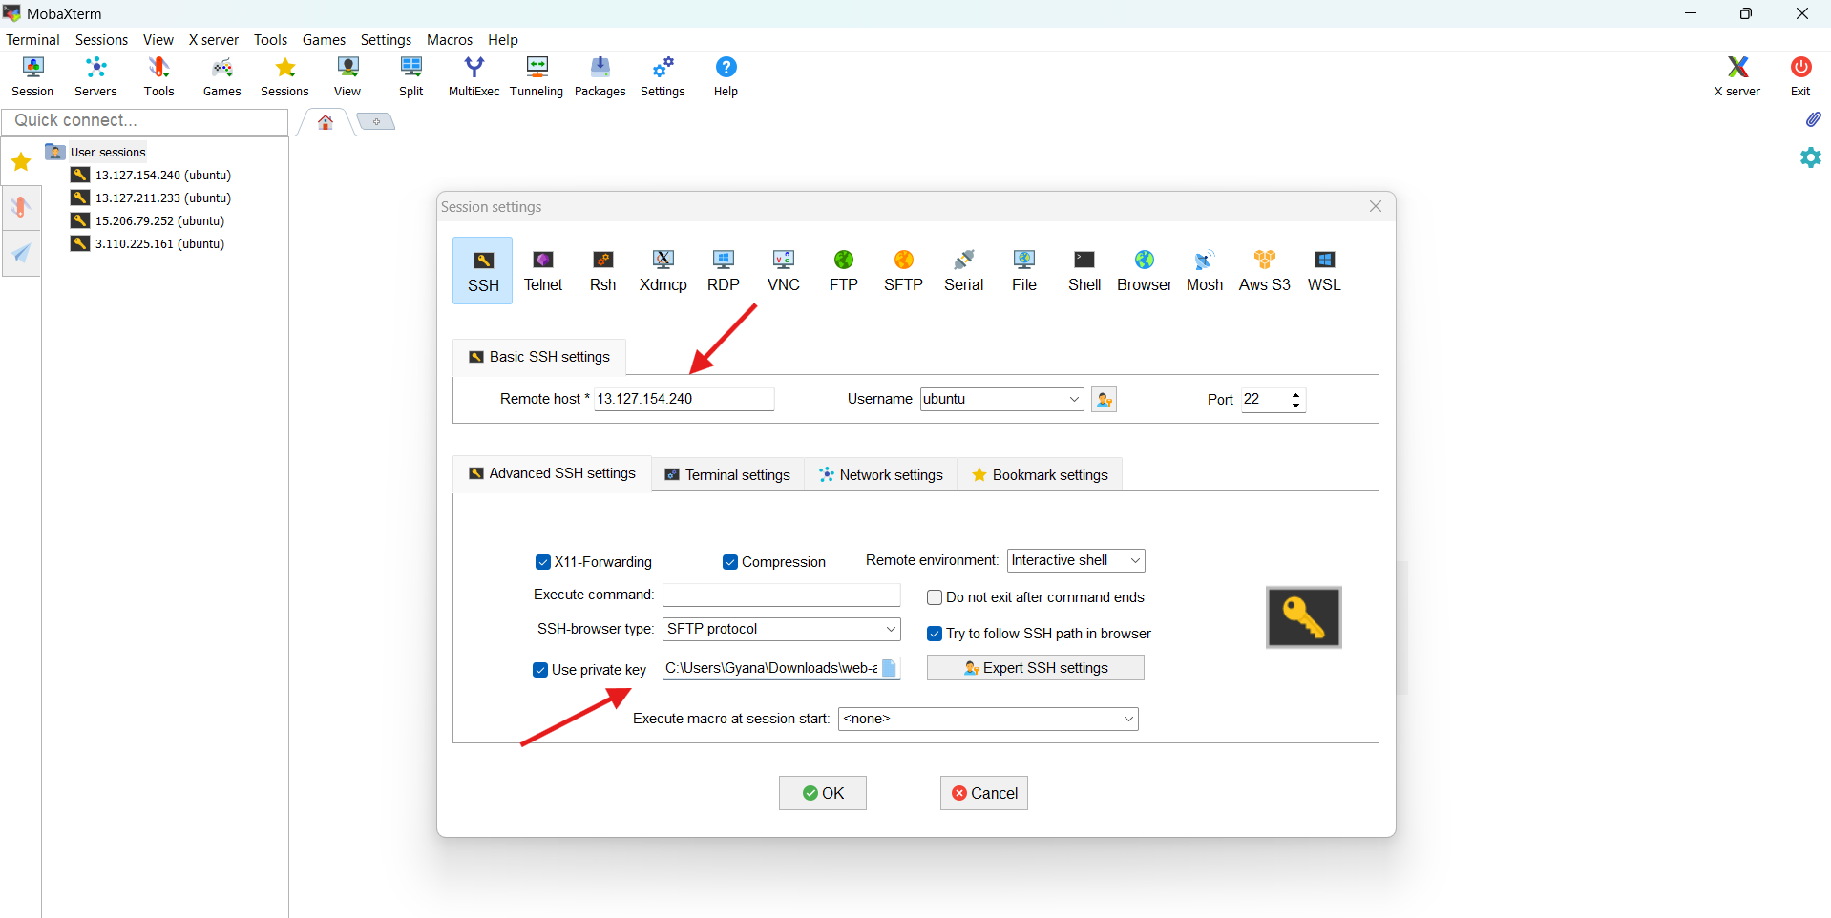
Setting up the docker apt repository
# Add Docker's official GPG key:
sudo apt update
sudo apt install ca-certificates curl
sudo install -m 0755 -d /etc/apt/keyrings
sudo curl -fsSL https://download.docker.com/linux/ubuntu/gpg -o /etc/apt/keyrings/docker.asc
sudo chmod a+r /etc/apt/keyrings/docker.asc

# Add the repository to Apt sources:
sudo tee /etc/apt/sources.list.d/docker.sources <<EOF
Types: deb
URIs: https://download.docker.com/linux/ubuntu
Suites: $(. /etc/os-release && echo "${UBUNTU_CODENAME:-$VERSION_CODENAME}")
Components: stable
Signed-By: /etc/apt/keyrings/docker.asc
EOF
sudo apt update
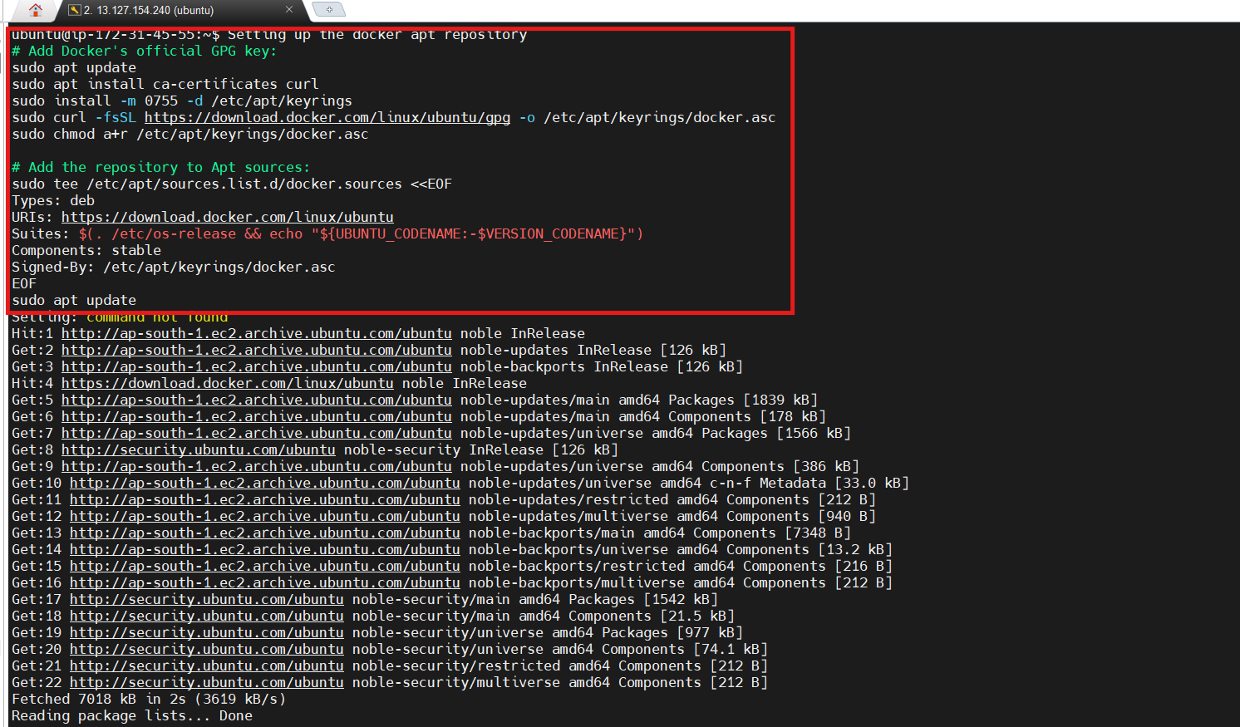

Install Latest version of Docker
sudo apt install docker-ce docker-ce-cli containerd.io docker-buildx-plugin docker-compose-plugin
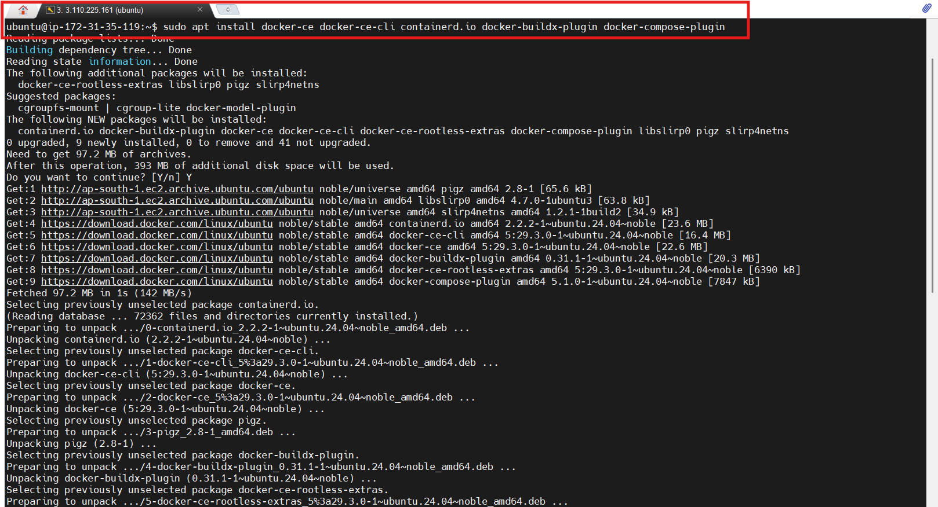
Change to the root user.
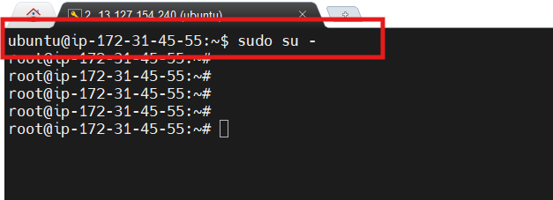
Verify the docker is running
- systemctl status docker
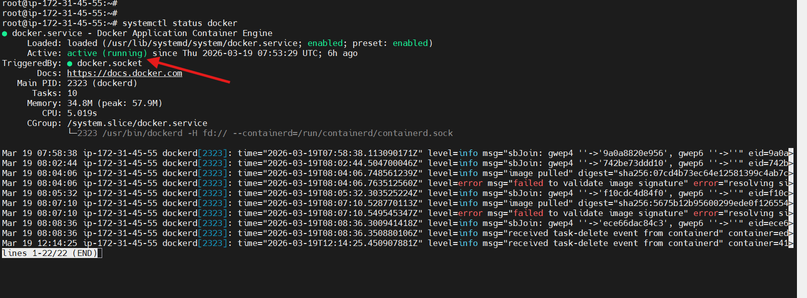
Check the Docker Version
- docker -v
- docker --version
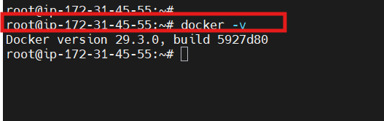
Check the Docker Images
- docker images
- docker image ls
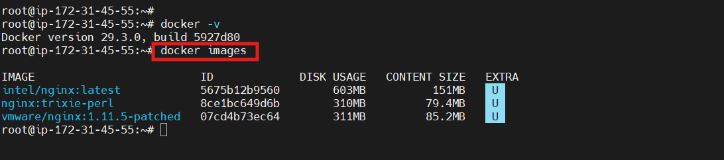

Assignmet-1
Create a Docker Container using customised name and run this container.
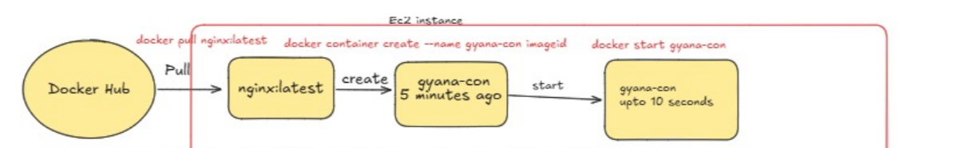

Pull the image from Docker Hub
- docker pull image-name
- docker pull nginx
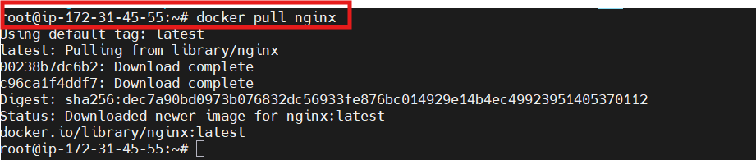
- docker images
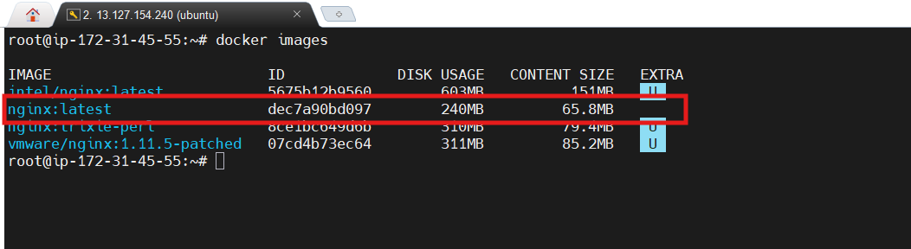
Create a docker container using Customised name
- docker container create --name gyana-con1 image-id
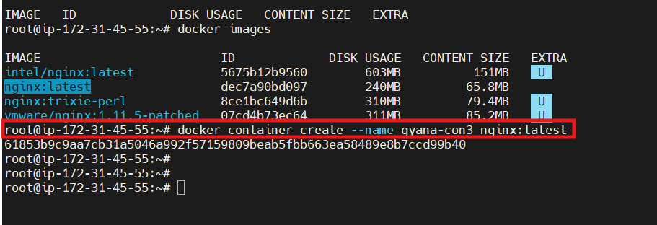
Check the Container
- docker ps -a
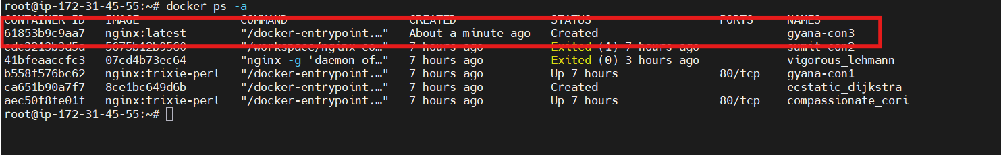

Run The container
- docker start container-name/container-id
- docker start container gyana-con3 (container can be optional )
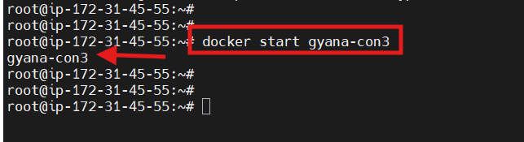
- Check the container is running
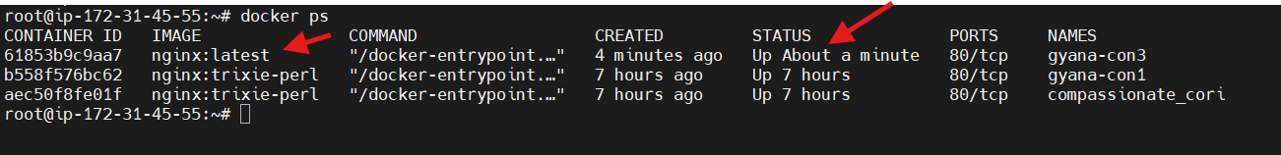

Assignmet-2
Create a container from image and start the container here docker engine will give the container name.
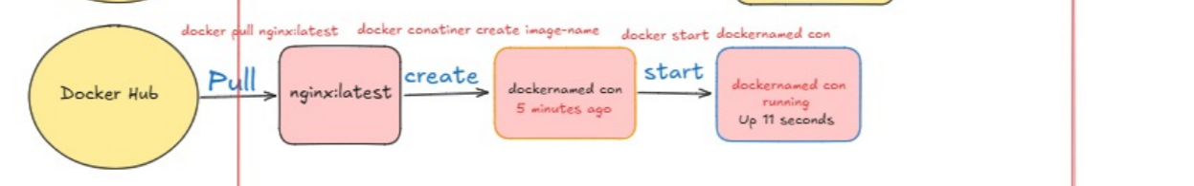
Pull the Image from Docker Hub
- docker pull nginx/nginx-ingress:edge-alpine
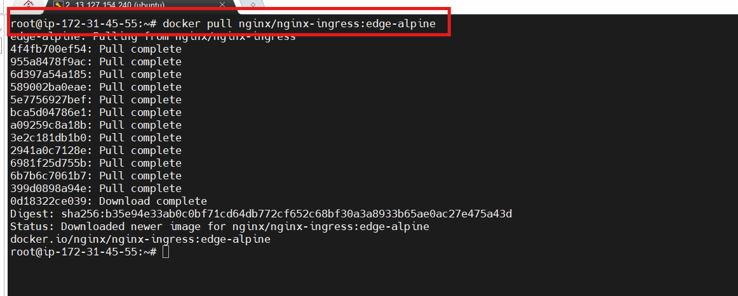

Create a Container
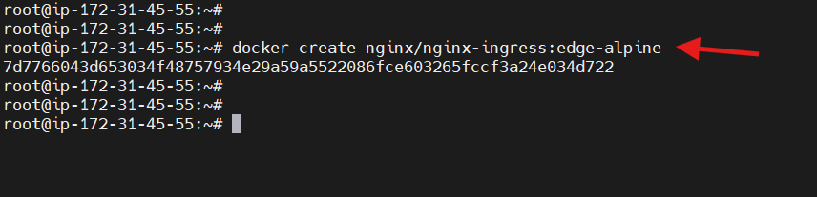
Check the container and container name
- docker ps -a
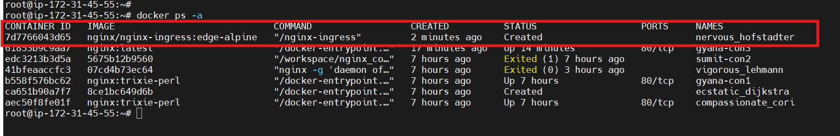
- Here the container name is given by the docker engine

Start & Run the container
- docker start container-name/container-id
- docker start nervous_hofstadter
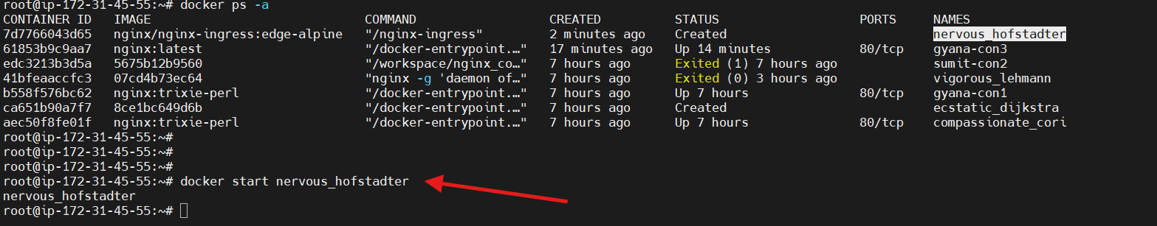

Check the container is running
- docker ps -a (This will check the container is running and which is stopped)
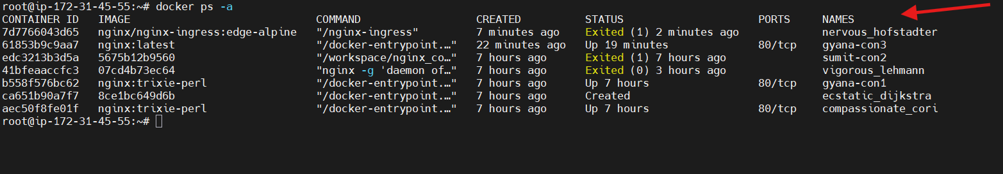

Assignmet-3
Pull the image and create and run the container at a time.
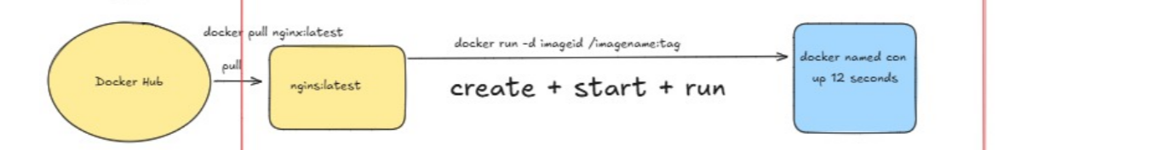
Pull the Image
- docker pull ubuntu/nginx:1.28-26.04_edge
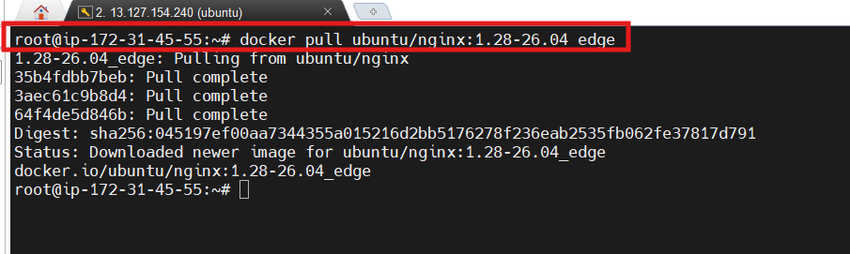
Check the Image
- docker images
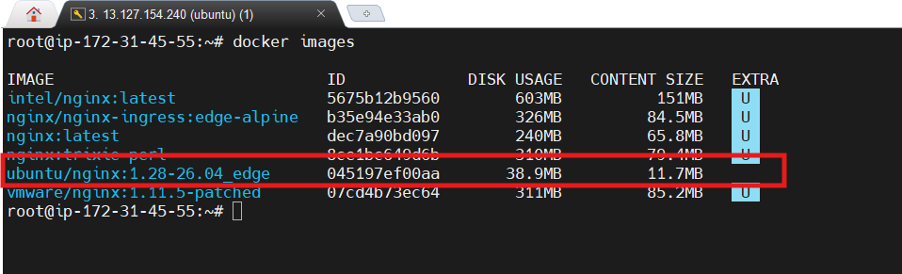

Start the Image
- docker run -d image-name/image-id
- docker run -d ubuntu/nginx:1.28-26.04_edge
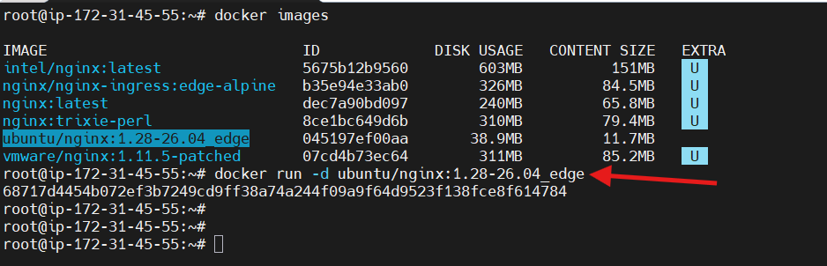

Check the Running Status
- docker ps
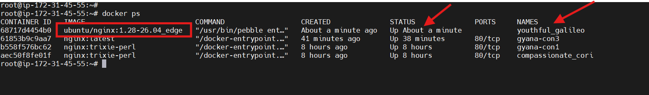
Container has creted successfully and also started with the name given by docker engine.

Assignment-4
Pull the image run the image using a customised name for the container
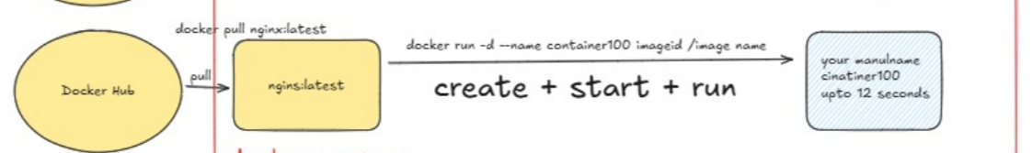

Pull The Image
- docker pull sonatype/nexus:pro-2.15.2-03
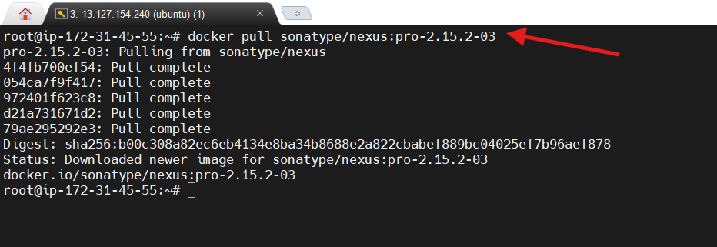

Start the image using the customised name for the container
- docker run -d --name container-name image-id/iamge-name
- docker run -d –name container100 b00c308a82ec (Image-id)
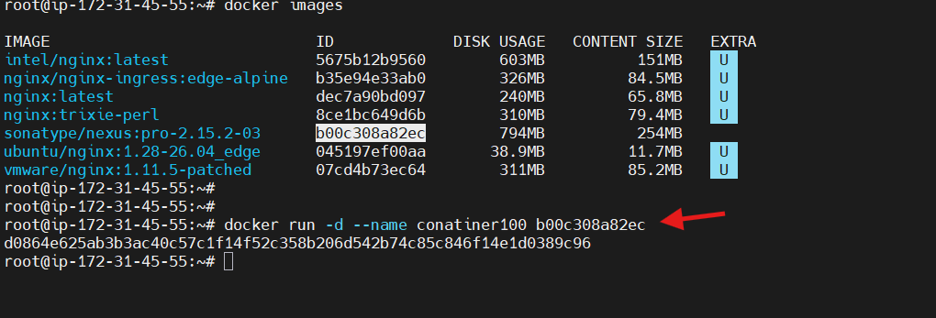

Check the running Status
- docker ps
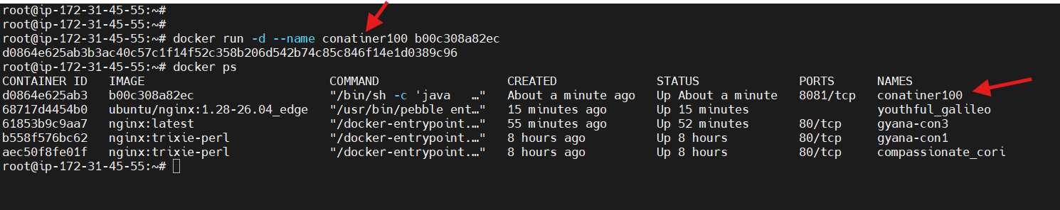
You can see docker container is running and the container name is showing .

